HOW TO: CONFIGURE JCL
This document provides step by step details on how you can configure your JCL for Batch Testing.
Prepared by: Diane Isabelle Lambojo

Input: JCL file
Output: JCL config in TSO
Pre-requisites:
- AWS log in account (SOE/RTC ID and password).
- TSO account credentials.
- JCL file
- SDS

Steps:
1. Login to AWS
1.1 Connect to wifi-delivery
1.2 Connect to GlobalProtect
1.3 Login to AWS using your RTC ID and password
2. Login to TSO
2.1 Open TSO inside AWS. Input ‘T’ then press Enter.
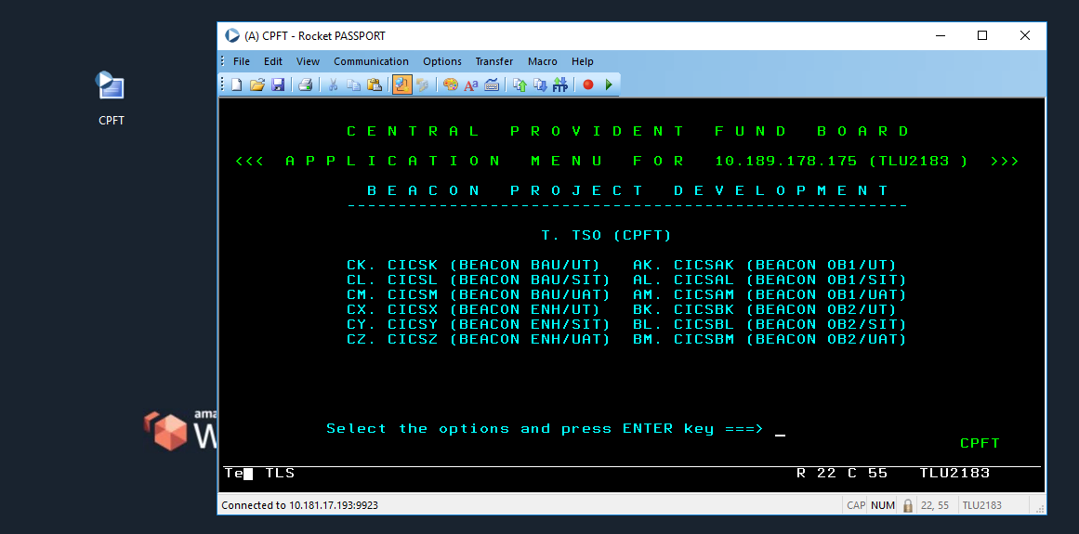

2.2 Login to TSO using your TSO account credentials.
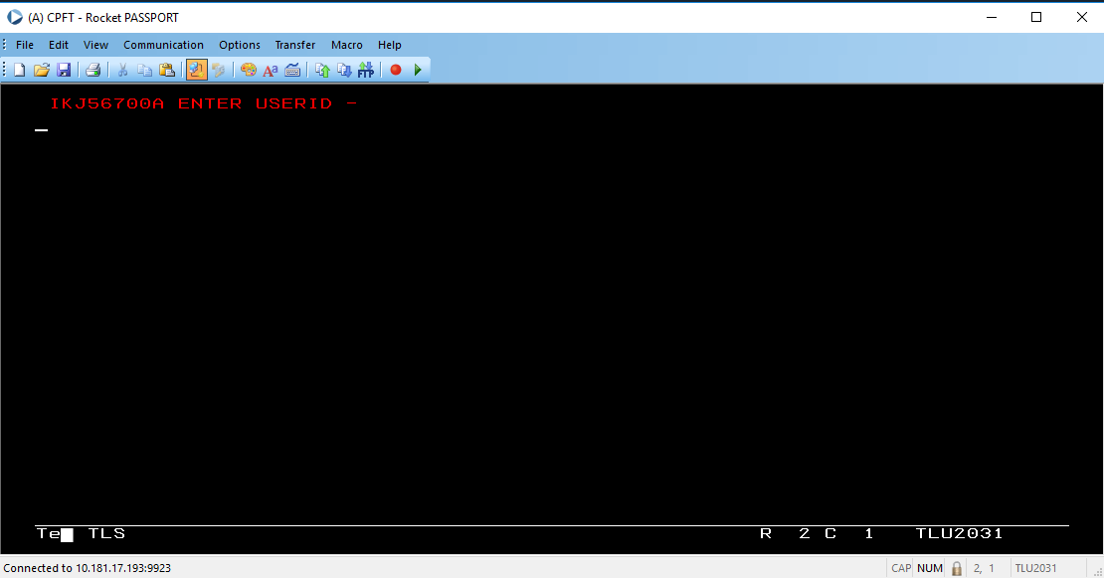
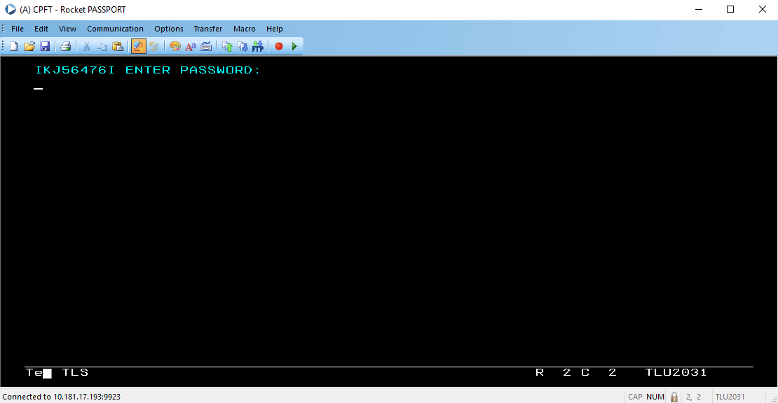

2.3 When you hit this menu, press Enter.
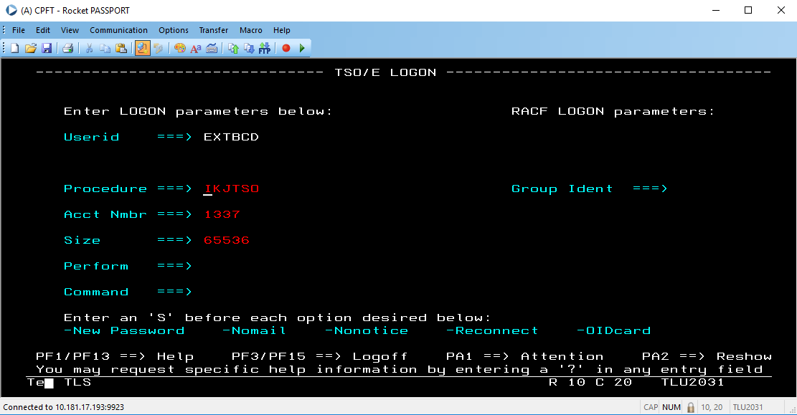

2.4 You will be redirected to this log menu. When you encounter these log messages, press Enter again.
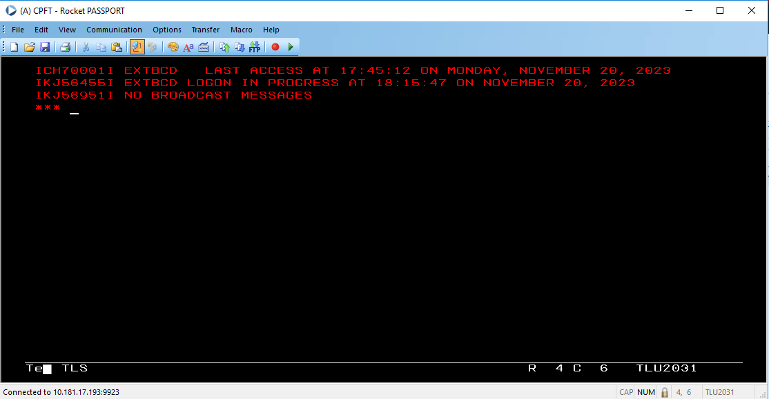
2.5 After being redirected to this menu, type in 3.4 beside the “option command” and press Enter.
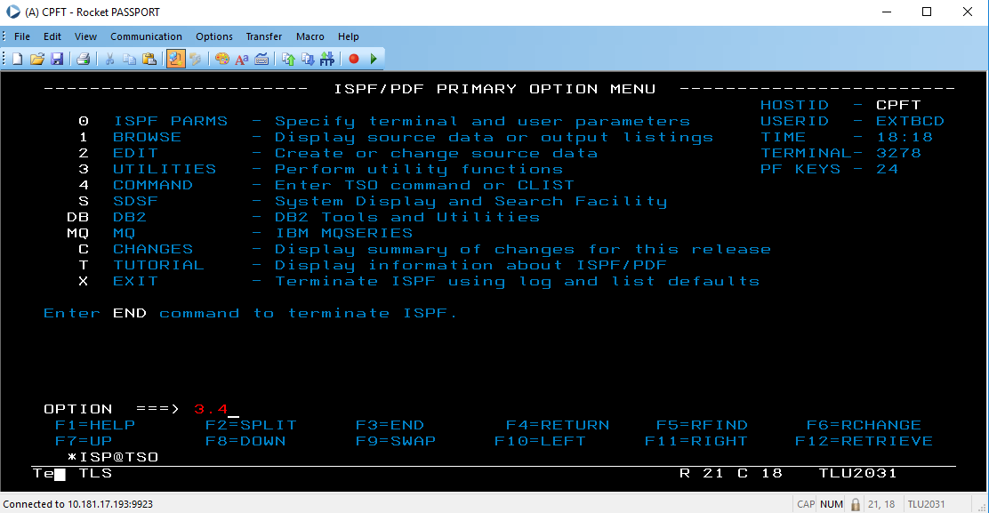

2.6 In this page, input your TSO ID in the Dsname Level and press Enter to access the folders inside the TSO ID you have specified.
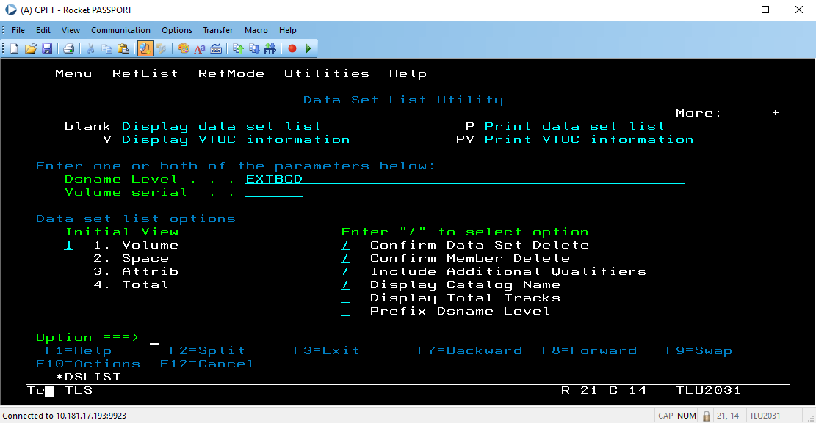
2.7 In this page you are now able to see and access your folders under this TSO ID.
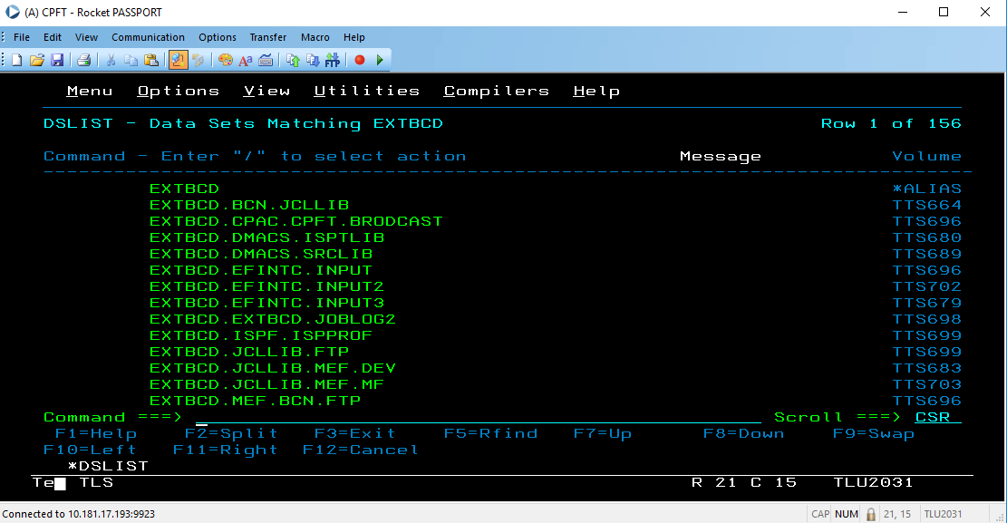

Things to remember before creating your JCL:
- You need to create 1 JCL config for Mainframe and 1 JCL config for Beacon for each batch job.
- You need to create 1 folder for Mainframe and 1 for Beacon.

3. Creating your Mainframe and Beacon Folder:
If you have existing folder inside your TSO:
3.1 Go to the existing folder, use the command / then press enter to show the options.
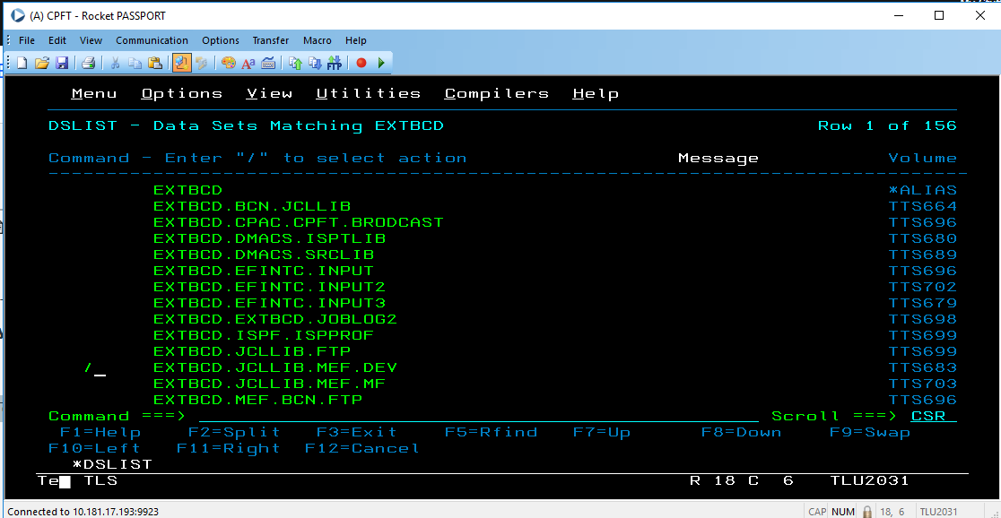

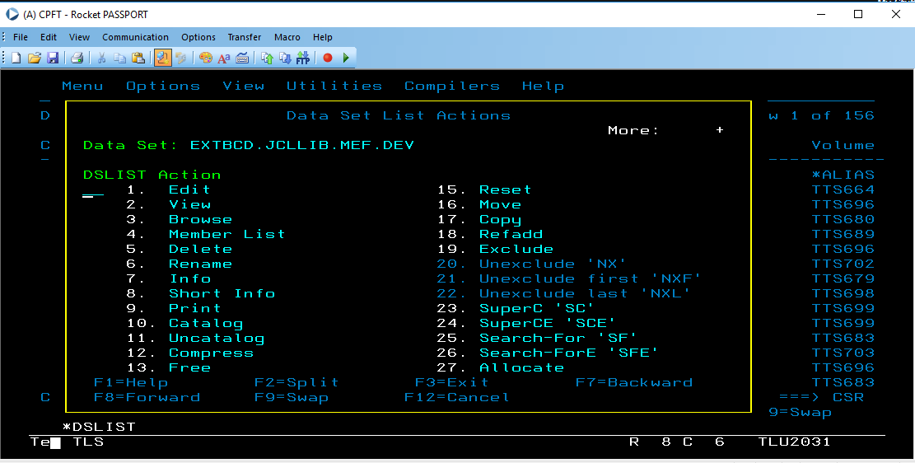

3.2 Type ‘17’ to choose the Copy option.
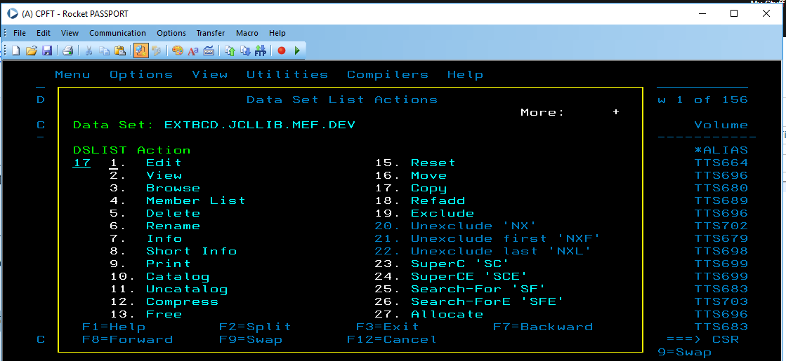
3.3 Then input the folder (where you will save it)
3.4 Rename the folder accordingly.

4. Creating your JCL Config – Mainframe
If there’s an existing JCL inside your TSO:
4.1 Go to the existing file, use the command / then press enter to show the options.
4.2 Type ‘17’ to choose the Copy option.

4.3 Then input the folder (where you will save it. Inside your mainframe or beacon folder).
4.4 Input the job name/ job id.
4.5 Then rename your JCL file accordingly.
4.6 Open your JCL and edit the content inside. Each batch job has a different configuration. Follow the JCL file you have.
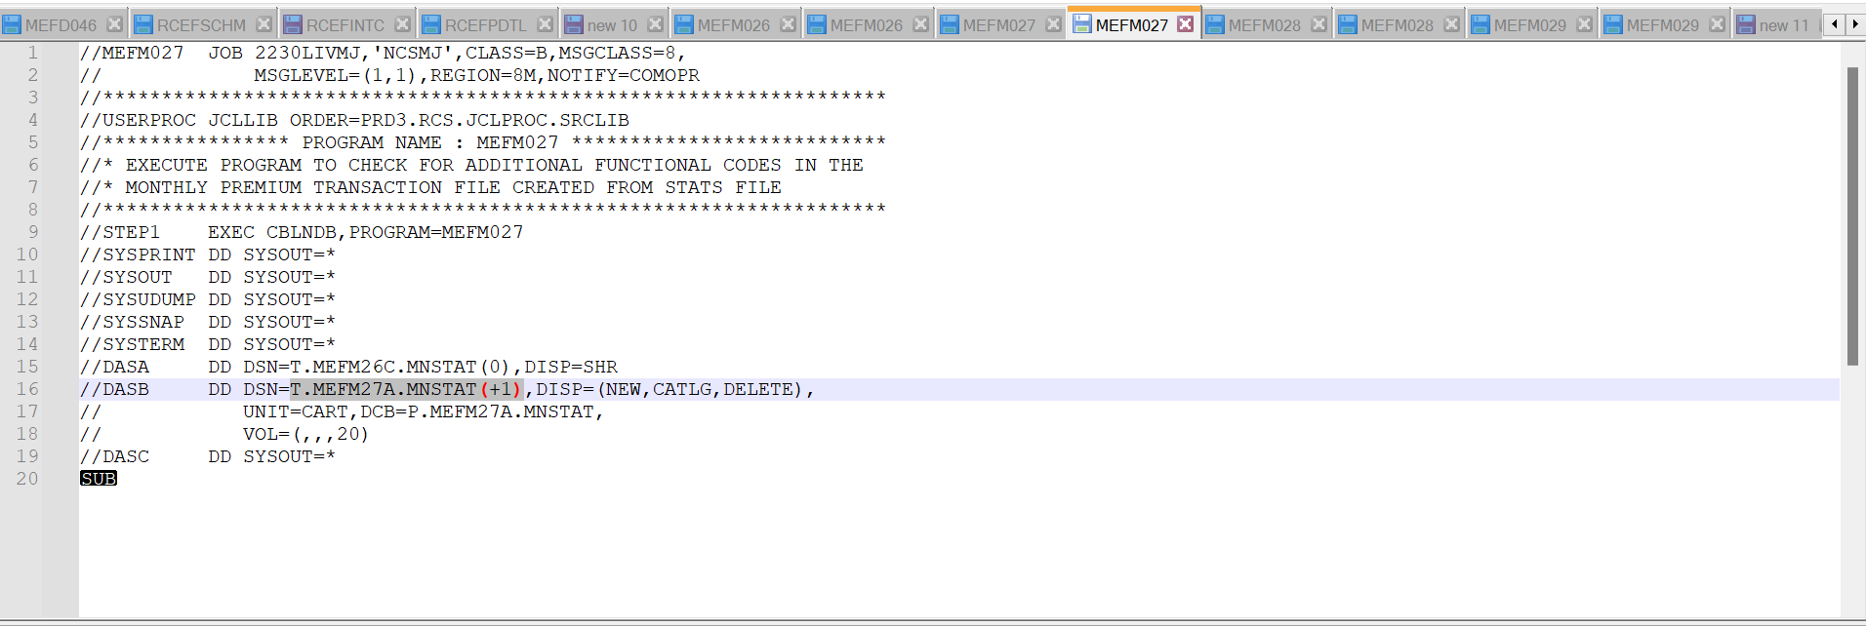
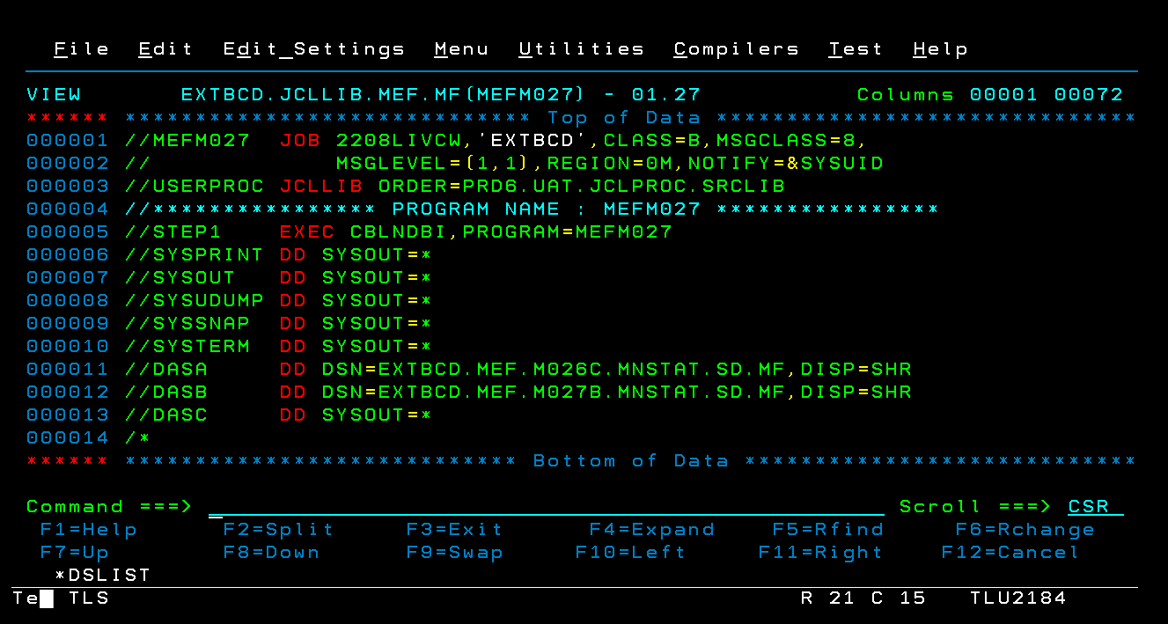
5. Creating your JCL Config – Beacon
In creating your JCL config for beacon, follow steps from 4.1 – 4.5 then proceed to the step below:
5.1 Open your JCL and edit the content inside. Each batch job has a different configuration. Follow the JCL config in your SDS.
